Updating the Extension (For In-Office Staff):

1. Go to the Extension Options page

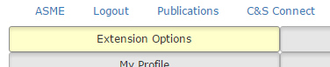

1. At the top of the page, click the “Extensions” link

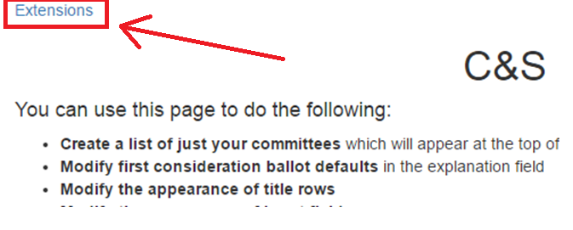

1. Click Reload next to the extension

